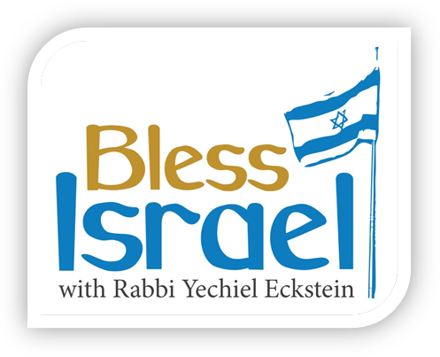
PROGRAM SUMMARY

Program Title: 037_Bless Israel_SPECIAL_Synagogue Attack

Source: Audio from Tele Town Hall Conference Call with Rabbi Yechiel Eckstein on 10/30/18 regarding the October 27 killing of 11 Jews at the Tree of Life Synagogue in Pittsburgh, PA.

CTA Ask: No financial Ask.

Website Promoted: www.ifcj.org/united

Phone Number Promoted: None

# CTAs in Program: 3 Total (Program Open, Mid-Point & Close)

Website → www.ifcj.org/united

037_Bless Israel_SPECIAL_Synagogue Attack

Transcript & CTA

INTRODUCTION TAG
The following program, “Bless Israel with Rabbi Yechiel Eckstein,” is brought to you by The International Fellowship of Christians and Jews, presenting the plight facing God's chosen people today so that you can be a blessing to them through your prayers and Christian love.

ANNOUNCER OPEN
On Saturday, October 27, 2018, tragedy hit the heart of America.

We experienced a horrific attack at the Tree of Life Synagogue in Pittsburgh that claimed the lives of 11 innocent Jews.

The prayers of our entire Fellowship family go out to our Jewish brothers and sisters who came to worship God on that tragic day.

Together with millions around the world, we are praying for those who lost their lives, the injured, their families and for the protection of Israel and her people.

This attack is a call to action for us all.

The Pittsburgh Tree of Life Synagogue is one more example of a disturbing and growing pattern of hatred and anti-Semitism against Jews around the world.

You can UNITE with The Fellowship against anti-Semitism when you visit I-F-C-J DOT ORG SLASH UNITED. THAT’S I-F-C-J DOT ORG SLASH UNITED.

Rabbi Yechiel Eckstein, President and Founder of The International Fellowship of Christians and Jews, spoke to over 10,000 friends of Israel on a Town Hall Conference Call about the tragedy in Pittsburgh.

Let’s listen…

RABBI YECHIEL ECKSTEIN
TELE TOWN HALL
Part 1

ANNOUNCER MID-POINT

You’re listening to Rabbi Yechiel Eckstein, President and Founder of The International Fellowship of Christians and Jews, here on our BLESS ISRAEL program, as he spoke to over 10,000 friends of Israel on a Town Hall Conference Call about the tragedy in Pittsburgh where 11 Jews were killed at the Tree of Life Synagogue.

As people of faith, attacks against Jews — in Pittsburgh, Jerusalem or any place in the world — are attacks against us all.

You can UNITE with The Fellowship against anti-Semitism when you visit I-F-C-J DOT ORG SLASH UNITED. THAT’S I-F-C-J DOT ORG SLASH UNITED.

Let’s return now to the Fellowship’s Tele-Town Hall Conference with Rabbi Yechiel Eckstein.

RABBI YECHIEL ECKSTEIN
TELE TOWN HALL
Part 2

We’ve come to the end of our program today here on BLESS ISRAEL.

What you’ve been listening to is Rabbi Yechiel Eckstein, President and Founder of The International Fellowship of Christians and Jews, and a heartfelt message he shared to over 10,000 friends of Israel on a Town Hall Conference Call about the tragedy in Pittsburgh where 11 Jews were killed at the Tree of Life Synagogue.

The Pittsburgh attack is just one more example of a disturbing and growing pattern of hatred and prejudice that has been taking shape for years against Jews around the world.

As people of faith, attacks against Jews – in Pittsburgh, Jerusalem, or any other place in the world – are attacks against all of us.

To help protect hundreds of thousands of Jews, The Fellowship has been providing security guards, cameras, and other protective equipment to synagogues, Jewish schools, and other Jewish institutions around the world.

The Fellowship also provides security for hundreds of thousands of Jewish people in over 180 cities in Israel and around the world, including France, Belgium, Argentina, Brazil, Ukraine, Russia, Spain, and Turkey, where threats from terrorism and anti-Semitism are evident.

We hope you will continue to join with us in providing security for these Jewish institutions.

The International Fellowship of Christians and Jews is standing with the Jewish people.

You can UNITE with The Fellowship against anti-Semitism when you visit I-F-C-J DOT ORG SLASH UNITED. THAT’S I-F-C-J DOT ORG SLASH UNITED.

Thanks for listening.

Announcer Closing Tag
“Bless Israel with Rabbi Yechiel Eckstein,” is the radio ministry of The International Fellowship of Christians and Jews.

